using System;

namespace Abdullah_Sadiq_CP_Lab_3
{
class Program
{
static void Main(string[] args)
{
Console.WriteLine("Enter your Name");
String name = Console.ReadLine();
Console.WriteLine("Enter Your Age");
int age = Convert.ToInt32(Console.ReadLine());
Console.WriteLine("Enter your salary");
int salary = Convert.ToInt32(Console.ReadLine());
Console.WriteLine("Enter Your Height");
double Height = Convert.ToDouble(Console.ReadLine());
Console.WriteLine("|\tName:{0}\t|\n|\tAge:{1} \t|\n|\tSalary:{2} \t|\n|\tHeight:{3} \t|", name,age,salary,Height);

}
}
}
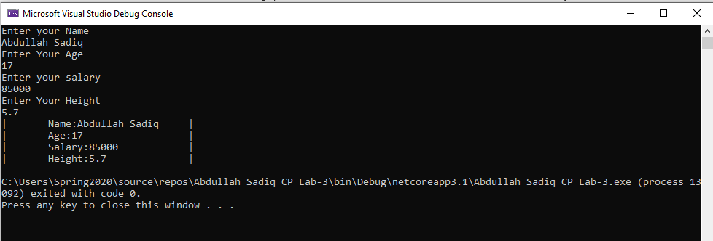

Task No 01: Convert Fahrenheit to Celsius
Input:
using System;

namespace Abdullah_Sadiq_CP_Lab_3
{
class Program
{
static void Main(string[] args)
{
Console.WriteLine("Enter Temperature in Fahrenheit");
int f = Convert.ToInt32(Console.ReadLine());
int c = (f - 32)*5/9;
Console.WriteLine("The Temperature in Celcius is {0}", c);

}
}
}
Output
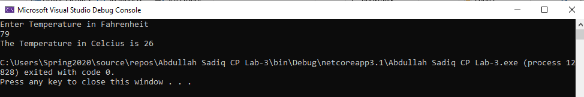
Task No 02: Calculate Area Of Circle
Input:
using System;

namespace Abdullah_Sadiq_CP_Lab_3
{
class Program
{
static void Main(string[] args)
{
int r = 8;
Console.WriteLine("Radius = 8cm");
Console.WriteLine("Pie = 22/7");
float a = r * r * 22 / 7;
Console.WriteLine("Area of Circle is {0}", a);

}
}
}
Output;
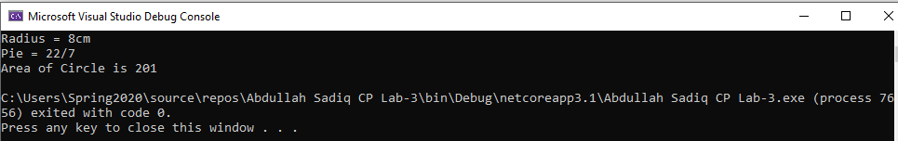
Task No 03: calculate value of Vf from equation of motion
Input:
using System;

namespace Abdullah_Sadiq_CP_Lab_3
{
class Program
{
static void Main(string[] args)
{
int vi = 43;
int a = 3;
int t = 15;
Console.WriteLine("Initial Velocity is 43 m/s");
Console.WriteLine("Time = 15s");
Console.WriteLine("Acceleration = 3m/ss");
int vf = vi = a * t;
Console.WriteLine("Final Velocity is {0}", vf);
}
}
}
Output:
